Name: Anirban Das Batch: BCSE-II Session: 2020-21
Roll No.: 001910501077
Second Semester Experiments in Microprocessor Lab

Problem Sheet #1

1. Load the contents of the memory locations 2200H and 2201H into registers. Add these registers and store the result in memory locations 2202H and 2203H.

Line# | Address in Hex | Label | Instruction | Opcode (in hex) | Remarks
1 | 0800 |  | LDA 2200H | 3A | A = M[2200H]
2 | 0801 |  | LDA 2200H | 00 | A = M[2200H]
3 | 0802 |  | LDA 2200H | 22 | A = M[2200H]
4 | 0803 |  | MOV H, A | 67 | H = A
5 | 0804 |  | LDA 2201H | 3A | A = M[2201H]
6 | 0805 |  | LDA 2201H | 01 | A = M[2201H]
7 | 0806 |  | LDA 2201H | 22 | A = M[2201H]
8 | 0807 |  | MOV L, A | 84 | L = A
9 | 0808 |  | MVI A, 00H | 6F | A = 00H
10 | 0809 |  | MVI A, 00H | 3E | A = 00H
11 | 080A |  | ADC A | 00 | A = A + Cy
12 | 080B |  | ADC A | 8F | A = A + Cy
13 | 080C |  | MOV H,A | 67 | H = A
14 | 080D |  | SHLD 2202H | 22 | M[2202H] = L  M[2203H] = H
15 | 080E |  | SHLD 2202H | 02 | M[2202H] = L  M[2203H] = H
16 | 080F |  | SHLD 2202H | 22 | M[2202H] = L  M[2203H] = H
17 | 0810 |  | HLT | 76 | Halt

Simulator with loaded machine code:

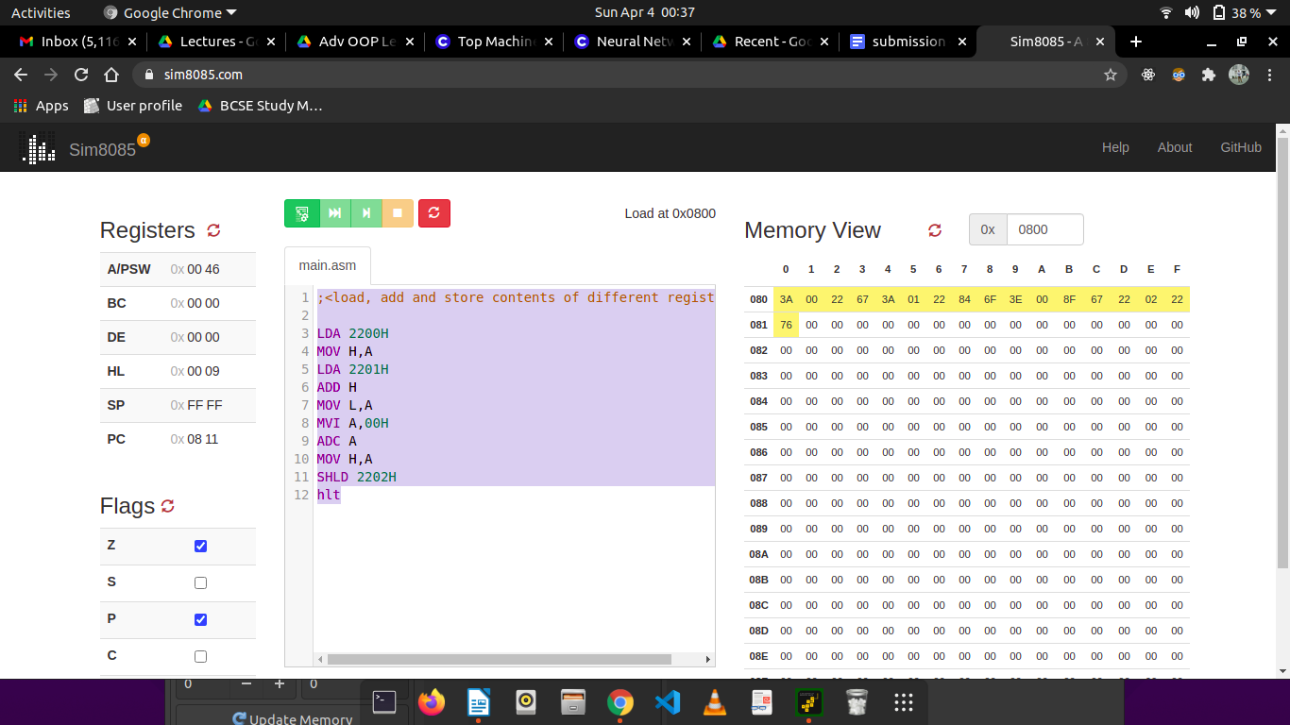

Sample input and output (M[2200H] = FFH, M[2201H] = F0H; ABH + CDH = 01EFH)

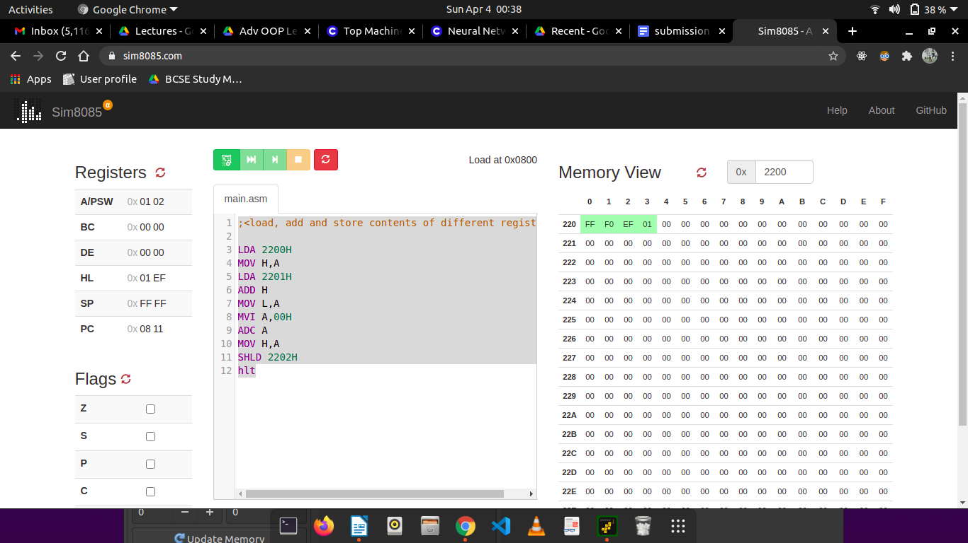

2. Find the sum of N numbers stored in consecutive locations starting from 2500H. The value of N is stored in 2200H. Store the result in locations 2300H and 2301H.

Line# | Address in Hex | Label | Instruction | Opcode in Hex | Remarks
03 | 0800 |  | LXI H, 2200H | 21 | Store value of N
 | 0801 |  | LXI H, 2200H | 00 | Store value of N
 | 0802 |  | LXI H, 2200H | 22 | Store value of N
04 | 0803 |  | MOV C, M | 4E | C = M
06 | 0804 |  | LXI H, 2500H | 21 | Store starting address
 | 0805 |  | LXI H, 2500H | 00 | Store starting address
 | 0806 |  | LXI H, 2500H | 25 | Store starting address
07 | 0807 |  | XRA A | AF | Clear Accumulator
08 | 0808 |  | MOV E,A | 5F | E = A
10 | 0809 | LOOP: | ADD M | 86 | These 3 steps add to E; preserving flags
11 | 080A |  | JNC SKIP | D2 | SKIP => Cy = 0
 | 080B |  | JNC SKIP | 0E | SKIP => Cy = 0
 | 080C |  | JNC SKIP | 00 | SKIP => Cy = 0
12 | 080D |  | INR E | 1C | If carry generated, increment E (higher byte)
14 | 080E | SKIP: | DCR C | 0D | Decrement counter
15 | 080F |  | INX H | 23 | Go to next input
16 | 0810 |  | JNZ LOOP | C2 | Loop back to add if numbers left
 | 0811 |  | JNZ LOOP | C9 | Loop back to add if numbers left
 | 0812 |  | JNZ LOOP | 00 | Loop back to add if numbers left
18 | 0813 |  | LXI H, 2300H | 21 | Load H with address 2300H
18 | 0814 |  | LXI H, 2300H | 00 | Load H with address 2300H
18 | 0815 |  | LXI H, 2300H | 23 | Load H with address 2300H
99 | 0816 |  | MOV M, A | 77 | M = A
20 | 0817 |  | INX H | 23 | Go to next input
21 | 0818 |  | MOV M, E | 73 | M = E
23 | 0819 |  | HLT | 76 | Halt

Simulator with loaded machine code:

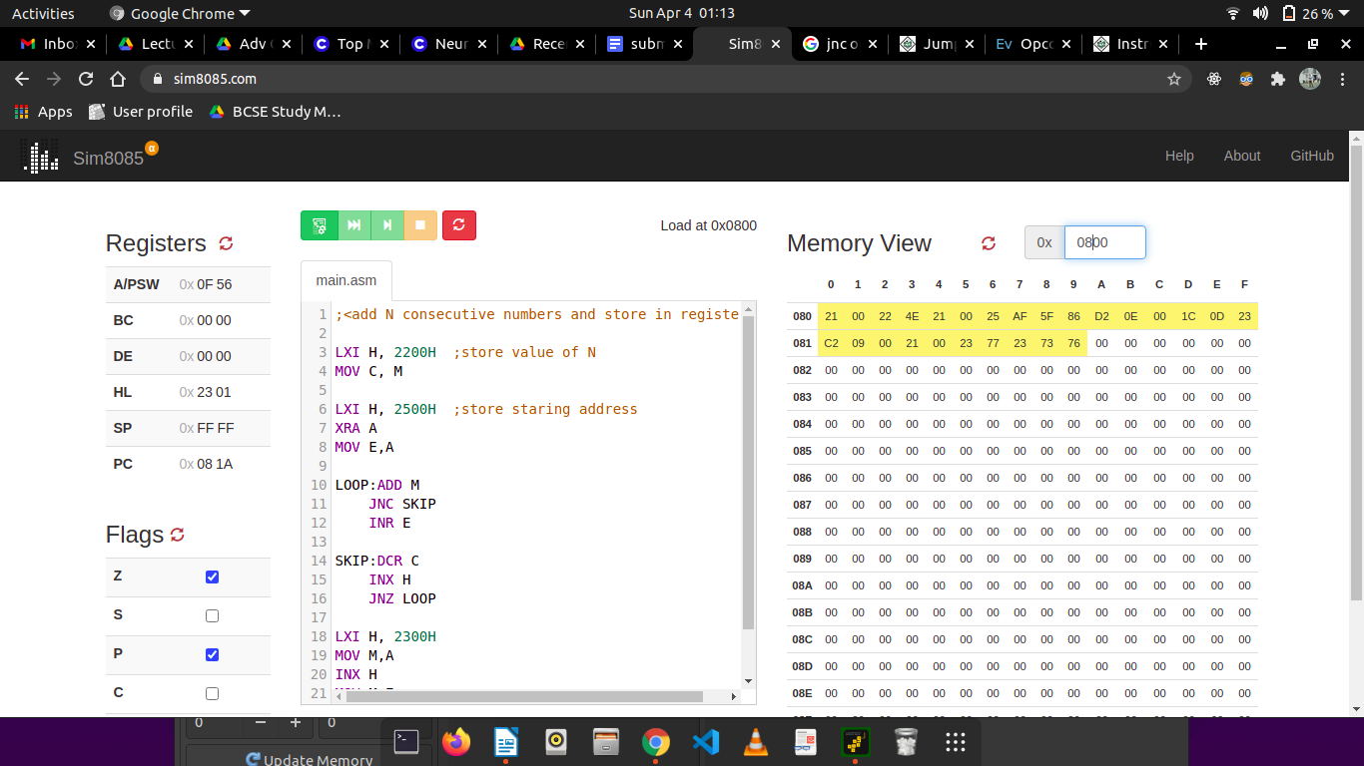

Sample input and output (M[2200H] = 05H, M[2500H] = 01H, M[2501H] = 02H, M[2502H] = 05H, M[2503H] = 04H, M[2504H] = 03H; M[2300H] = 0FH)

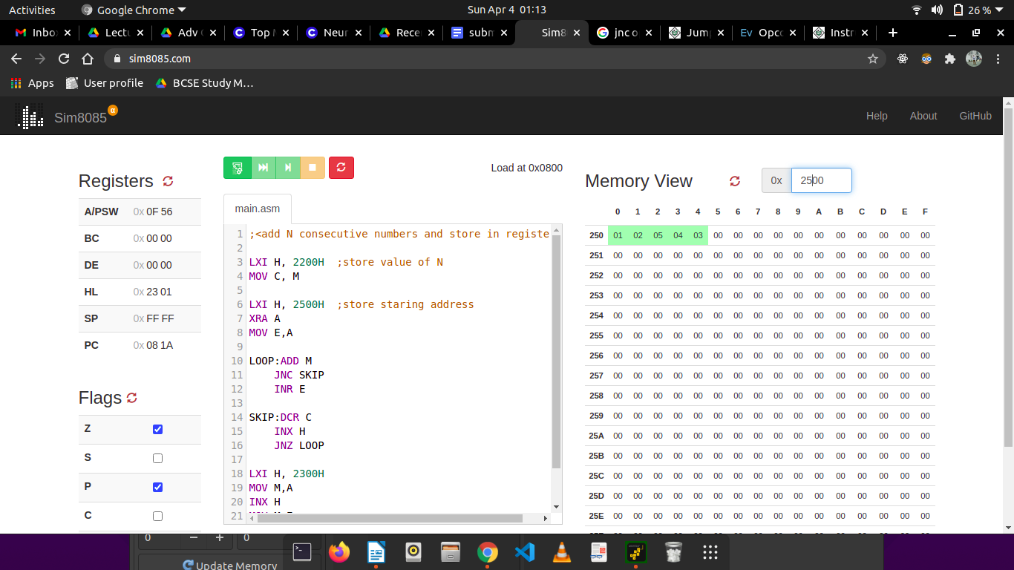
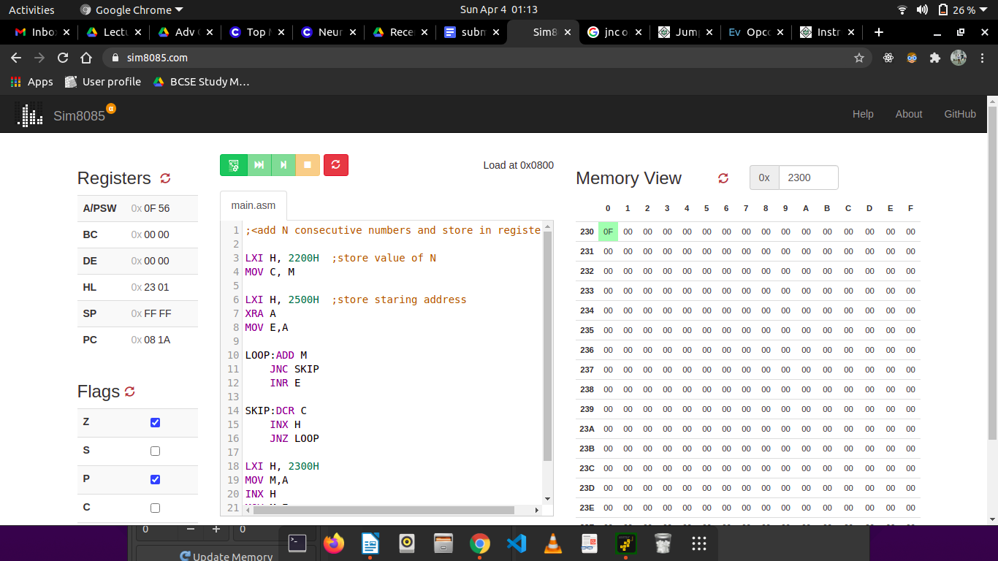

3. Find the sum of the least significant 4 bits and most significant 4 bits of a byte stored in memory location 2500H. Store the result in 2550H.

Line# | Address in Hex | Label | Instruction | Opcode in Hex | Remarks
1 | 0800 |  | LDA 2500H | 3A | Get input
2 | 0801 |  | LDA 2500H | 00 | Get input
3 | 0802 |  | LDA 2500H | 25 | Get input
4 | 0803 |  | MOV B,A | 47 | Save input because we need it twice
5 | 0804 |  | ANI 0FH | E6 | Get lower significant 4 bits
6 | 0805 |  | ANI 0FH | 0F | Get lower significant 4 bits
7 | 0806 |  | MOV D,A | 57 | D = lower significant 4 bits
8 | 0807 |  | MOV A,B | 78 | Get input number again
9 | 0808 |  | ANI F0H | E6 | Get higher significant 4 bits
10 | 0809 |  | ANI F0H | F0 | Get higher significant 4 bits
11 | 080A |  | RLC | 07 | Shift LEFT 4 times to bring them down to lower signficant position for addition
12 | 080B |  | RLC | 07
13 | 080C |  | RLC | 07
14 | 080D |  | RLC | 07
15 | 080E |  | ADD D | 82 | Perform required addition
16 | 080F |  | STA 2550H | 32 | Store to required target address
17 | 0810 |  | STA 2550H | 50 | Store to required target address
18 | 0811 |  | STA 2550H | 25 | Store to required target address
19 | 0812 |  | HLT | 76 | Halt

Simulator with loaded machine code:

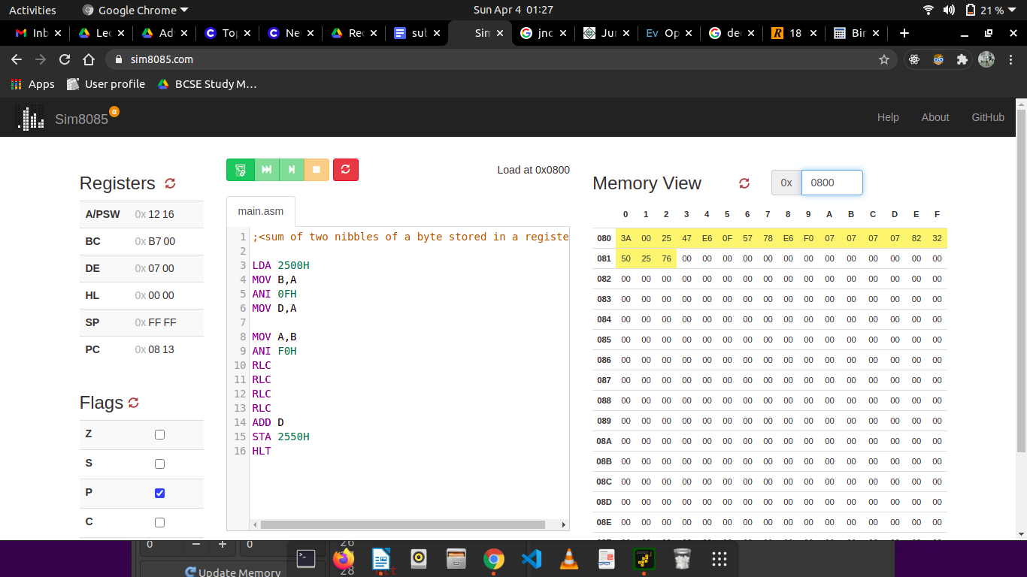
Sample input and output (M[2500H] = B7H, M[2550H] = 12H):
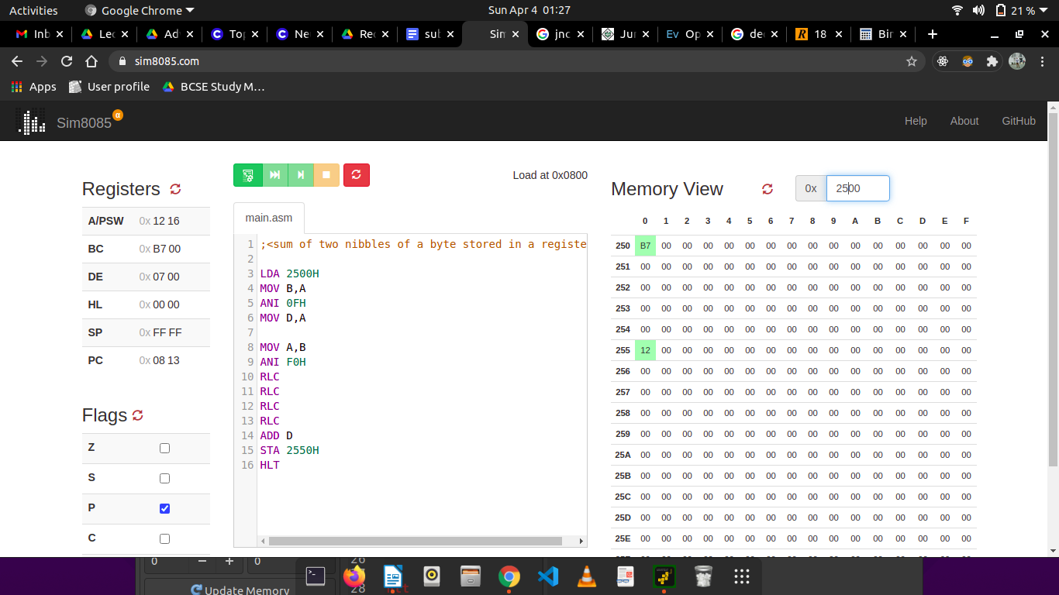

4. Write a program to count the ‘1’s and ‘0’s of a byte stored in 2500H. Store the result in 2610H and 2511H, respectively.

Line# | Address in Hex | Label | Instruction | Opcode in Hex | Remarks
1 | 0800 |  | LDA 2500H | 3A | Get the input
2 | 0801 |  | LDA 2500H | 00 | Get the input
3 | 0802 |  | LDA 2500H | 25 | Get the input
4 | 0803 |  | MVI D, 00H | 16 | This is the counter of 0s
5 | 0804 |  | MVI D, 00H | 00 | This is the counter of 0s
6 | 0805 |  | MVI C, 08H | 0E | This is the counter of total number of bits
7 | 0806 |  | MVI C, 08H | 08 | This is the counter of total number of bits
8 | 0807 | LOOP: | RRC | 0F | Right Shift the bits by 1
9 | 0808 |  | JC SKIP | DA | Jump to SKIP IF Cy = 1
9 | 0809 |  | JC SKIP | 0C | Jump to SKIP IF Cy = 1
9 | 080A |  | JC SKIP | 00 | Jump to SKIP IF Cy = 1
10 | 080B |  | INR D | 14 | If current bit is 0, D++
11 | 080C | SKIP: | DCR C | 0D | 1 bit checked, decrement C
12 | 080D |  | JNZ COUNT | C2 | Keep counting if not all bits have been checked
13 | 080E |  | JNZ COUNT | 07 | Keep counting if not all bits have been checked
14 | 080F |  | JNZ COUNT | 00 | Keep counting if not all bits have been checked
15 | 0801 |  | MOV A,D | 7A | Move the no. Of 0s to D
16 | 0802 |  | STA 2511H | 32 | Store the number of 0s
17 | 0803 |  | STA 2511H | 11 | Store the number of 0s
18 | 0804 |  | STA 2511H | 25 | Store the number of 0s
19 | 0805 |  | MVI A, 08H | 3E | A = 08H
20 | 0806 |  | SUB D | 92 | Get the no. Of 1s
21 | 0807 |  | STA 2611H | 32 | Store the no. Of 1s
21 | 0808 |  | STA 2611H | 10 | Store the no. Of 1s
21 | 0809 |  | STA 2611H | 26 | Store the no. Of 1s
22 | 081A |  | HLT | 76 | Halt

Simulator with loaded machine code:
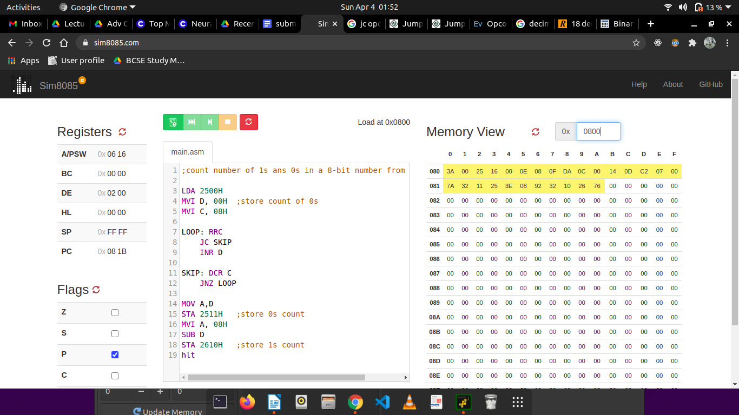
Sample input and output (M[2500H] = B7H; M[2510H] = 02H, M[2610H] = 06H):

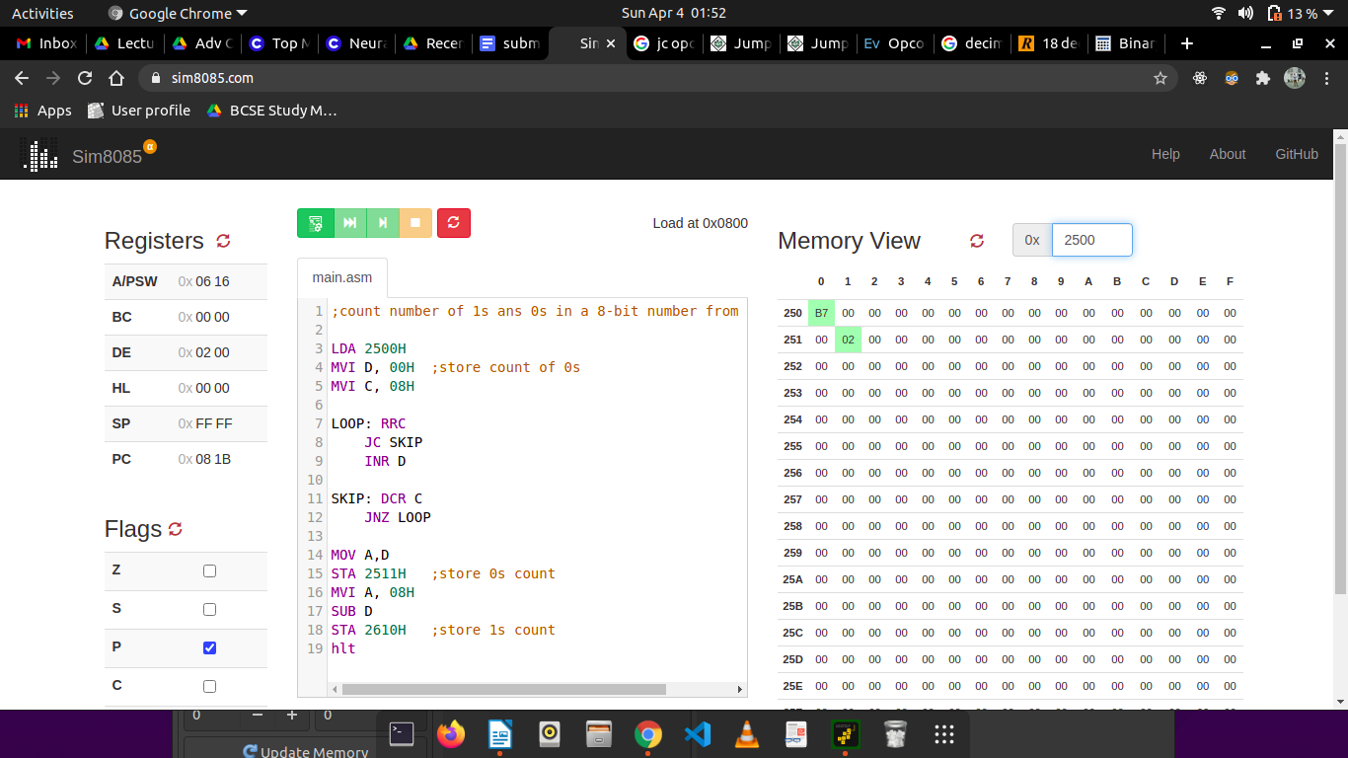
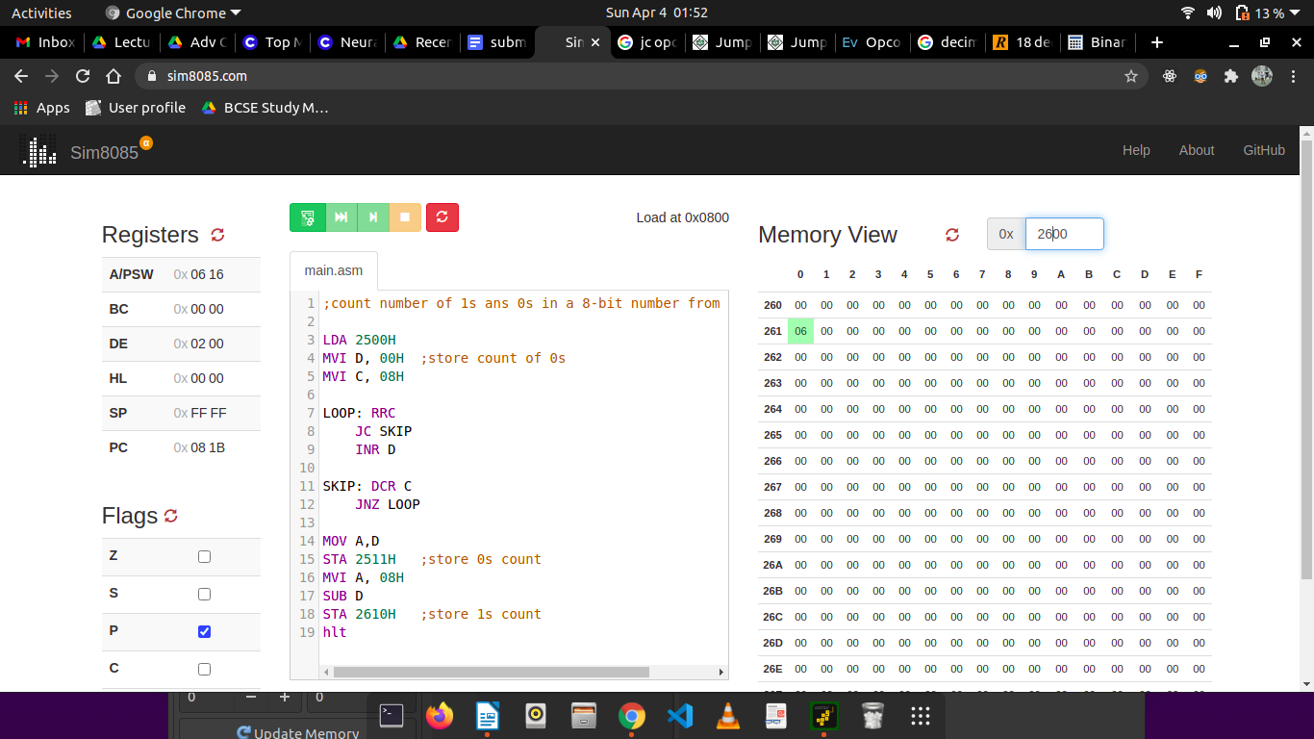

5. Write a program to sum two 16-bits binary numbers.

We will assume the 16-bit numbers are in 2200 and 2202H respectively, in little-endian order (lower significant byte first). We will store a 16-bit result in 2204H in the same manner.

Line# | Address in Hex | Label | Instruction | Opcode in Hex | Remarks
1 | 0800 |  | LHLD 2200H | 2A | Get first number
2 | 0801 |  | LHLD 2200H | 00 | Get first number
3 | 0802 |  | LHLD 2200H | 22 | Get first number
4 | 0803 |  | XCHG | EB | Swap DE and HL; we need DE = HL
5 | 0804 |  | LHLD 2202H | 2A | Get second number
6 | 0805 |  | LHLD 2202H | 02 | Get second number
7 | 0806 |  | LHLD 2202H | 22 | Get second number
8 | 0807 |  | DAD D | 19 | Add
9 | 0808 |  | SHLD 2204H | 22 | Store to target address
10 | 0809 |  | SHLD 2204H | 04 | Store to target address
11 | 080A |  | SHLD 2204H | 22 | Store to target address
 | 080B |  | MVI A, 00H | 3E | A = 00H
 | 080C |  | MVI A, 00H | 00 | A = 00H
 | 080D |  | ADC A | 8F | A = A + Cy
 | 080E |  | STA 2206 | 32 | Store the carry at address 2206H
 | 080F |  | STA 2206 | 06 | Store the carry at address 2206H
 | 0810 |  | STA 2206 | 22 | Store the carry at address 2206H
12 | 0811 |  | HLT | 76 | Halt

Simulator with loaded machine code:
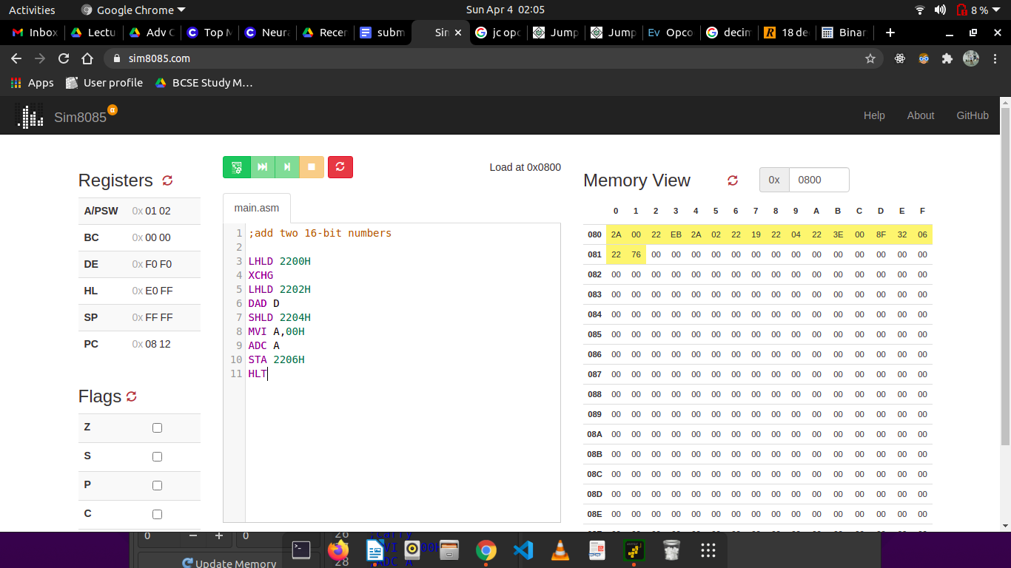

Sample input and output ( M[2200H , 2201H] = F0F0H, M[2202H , 2203H] = 0FF0H; M[2504H , 2505H] = FFE0H, M[2506H] = 01H ):

